Project 12: Bluetooth Control Smart Car
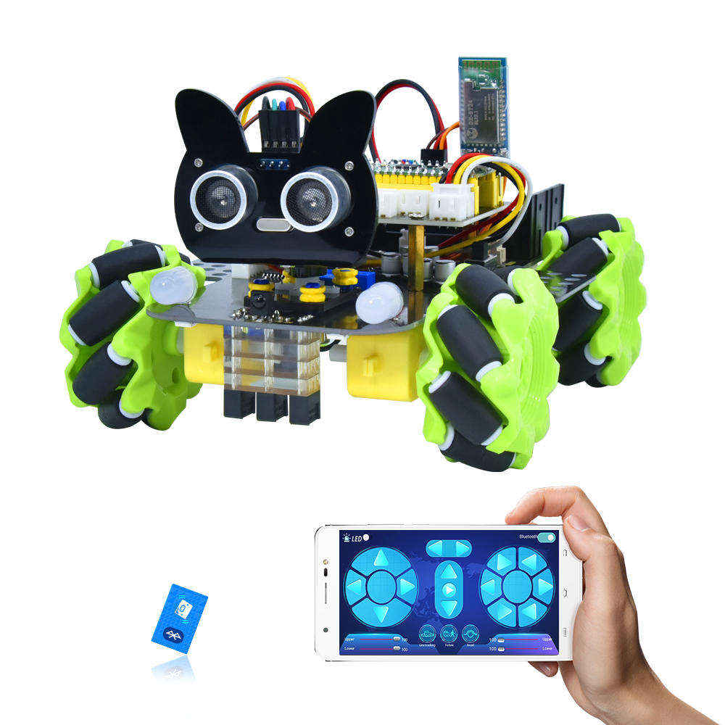

1. Description
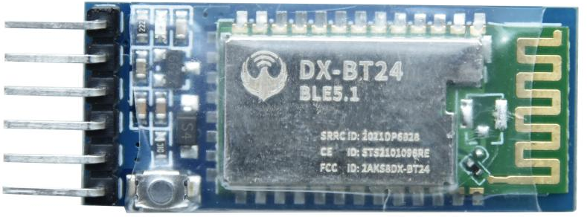
There is a DX-BT24 5.1 Bluetooth module in this kit. This Bluetooth module comes with 256Kb space and complies with V5.1 BLE Bluetooth specification, which supports AT commands. Users can change parameters such as the baud rate and device name of the serial port as required.
Furthermore, it supports UART interface and Bluetooth serial port transparent transmission, which also contains the advantages of low cost, small size, low power consumption and high sensitivity for sending and receiving. Notably, it solely needs a few peripheral components to realize its powerful functions.
In this project, we will use the BT24 Bluetooth module to combine all modules of the car in one code, which contains all functions except IR remote control mentioned in the previous projects. We plan to use mobile APP to connect Bluetooth module, so as to control various functions, which is distinctly simple and convenient.
We will work to read the control characters sent by each button through the Bluetooth connection of the APP.

2. Parameters
Bluetooth protocol：Bluetooth Specification V5.1 BLE
Working frequency：2.4GHz ISM band
Communication interface：UART
Power supply：5V/3.3V
Communication distance: 40m
Dimension：27(L)mm x 13 (W)mm x 2(H) mm
Bluetooth name：BT24
Serial port parameters：9600、eight data bits, one stop bit, no check, no flow control
Working temperature：MIN:-40℃ - MAX:+85℃

3. Test Code
/*
Keyestudio 4WD Mecanum Robot for Pico
lesson 12.1
APP Test
http://www.keyestudio.com
*/

char ble_val;
void setup() {
Serial1.begin(9600); //Set the baud rate to 9600
}

void loop() {
if (Serial1.available())//If the receiving area is not empty
{
char ble_val = Serial1.read();//Read the data of the bluetooth
Serial.println(ble_val);//The serial monitor prints the read data
}
}

4.Test Result
After uploading the code, plug in the Bluetooth, be careful not to plug it upside down. Connect the Bluetooth module and turn on the serial monitor.
Aim at the Bluetooth module and press the APP button of the mobile phone. We can see the corresponding control characters of the APP button, as shown below.
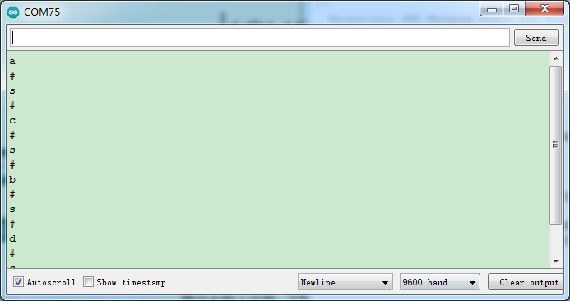

5. Code Explanation

Serial1.begin(9600); | Set the baud rate of the Bluetooth serial port to 9600. (Serial port 0 corresponds to Serial1, serial port 1 corresponds to Serial2 ).
Serial1.available() | If Bluetooth data is received, this value is not 0
char ble_val = Serial1.read(); | Read Bluetooth serial port data and define a variable of type char to save
Serial.println(ble_val);  Serial1.println(ble_val); | Upper : output to serial monitor  Lower: output data to Bluetooth module
Serial1.readStringUntil('#'); | Read the Bluetooth strings, stop reading if "#" appears, note that we use two consecutive such statements, because when we adjust speed, sending strings such as V# 50 #, we first read is "V" (#, then stop), the second read is "50", read here is string instead of an integer value
String(speed_str).toInt(); | Convert the numeric string read to an integer value
map(speed_Upper_L, 0, 100, 0, 255); | Since the speed value we send on our APP is 0~100, we have to map it to 0~ 255
speed_Upper_L  speed_Lower_L  speed_Upper_R  speed_Lower_R | Represents the speed values of the four motors.  Range is 0~255

- Comprehensive Project：APP Control Smart Car
/*
Keyestudio 4WD Mecanum Robot for Pico
lesson 12.2
APP Control Robot
http://www.keyestudio.com
*/

#include "MecanumCar_v2.h"
#include "rgb.h"
#include "ir.h"
#include "Servo.h"

mecanumCar mecanumCar(20, 21); //sda-->20,scl-->21
RGB rgb(7, 4); //rgb(pin, num); num = 0-100
Servo myservo;
IR IRreceive(6);//IR receiver is connected to GP6

/*******Ultrasonic Sensor interface*****/
#define EchoPin 4 //ECHO to GPIO4
#define TrigPin 3 //TRIG to GPIO3

/*******Define the pin of line tracking sensor**********/
#define SensorLeft 16 //input pin of left sensor
#define SensorMiddle 17 //input pin of middle sensor
#define SensorRight 18 //input pin of right sensor

String speed_str;
int color_num = 0;
char ble_val;

void setup() {
/*Bluetooth serial port is set to UART0,TX为GPIO0*/

/*Bluetooth serial port is set to UART0,RX为GPIO1*/
Serial1.begin(9600); //Set the Bluetooth string baud rate to 9600

pinMode(EchoPin, INPUT); //The ECHO pin is set to input mode
pinMode(TrigPin, OUTPUT); //The TRIG pin is set to output mode

/****All interfaces of the line tracking sensor are set to input mode***/
pinMode(SensorLeft, INPUT);
pinMode(SensorMiddle, INPUT);
pinMode(SensorRight, INPUT);

myservo.attach(2); // attaches the servo on GPIO2 to the servo object
myservo.write(90);
delay(500);

rgb.setBrightness(100); //rgb.setBrightness(0-255);
delay(10);
rgb.clear(); //Turn off all leds
delay(10);
rgb.show();

mecanumCar.Init(); //Initialize the seven-color LED and motor drive
}

void loop() {
int key = IRreceive.getKey();
if (key != -1) {
//Serial.println(key);
switch (key)
{
case 64: mecanumCar.Stop(); break; //Stop
case 70: mecanumCar.Advance(); break; //Go ahead
case 21: mecanumCar.Back(); break; //Move back
case 68: mecanumCar.Turn_Left(); break; //Turn left
case 67: mecanumCar.Turn_Right(); break; //Turn right
}
}
if (Serial1.available())//If the receiving area is not empty
{
ble_val = Serial1.read();//Read the data of the bluetooth
Serial.println(ble_val);//The serial monitor prints the read data
switch (ble_val)
{
/*********************The car driving************************/
case 's': mecanumCar.Stop(); break; //Stop
case 'a': mecanumCar.Advance(); break; //Go ahead
case 'c': mecanumCar.Back(); break; //Move back
case 'b': mecanumCar.Turn_Left(); break; //Turn left
case 'd': mecanumCar.Turn_Right(); break; //Turn right
case 'k': mecanumCar.L_Move(); break; //Left shift
case 'h': mecanumCar.R_Move(); break; //Right shift
case 'l': mecanumCar.LU_Move(); break; //Upper left move
case 'j': mecanumCar.LD_Move(); break; //lower left move
case 'g': mecanumCar.RU_Move(); break; //Upper right move
case 'i': mecanumCar.RD_Move(); break; //lower right move
case 'e': mecanumCar.drift_left(); break; //Drift
case 'f': mecanumCar.drift_right(); break; //Drift

case 'p': Line_Tracking(); break; //Tracking
case 'q': ult_following(); break; //Follow
case 'r': ult_avoiding(); break; //Obstacle Avoidance

/*********************The light of the car*************************/
case 't': mecanumCar.right_led(1); mecanumCar.left_led(1); break; //Open the 7-color LED
case 'u': mecanumCar.right_led(0); mecanumCar.left_led(0); break; //Close the 7-color LED
case 'm': color_num++; showColor(); break; //Switching the color of 2812 LED
case 'o': rgb.clear(); break; //Close the 2812 LED
case 'n': color_num--; showColor(); break; //Switching the color of 2812 LED
/*********************The car changes speed*************************/
case 'v': /*Read left front motor M2 speed*/
Serial1.readStringUntil('#'); //Fail to read data the first time, read once
speed_str = Serial1.readStringUntil('#'); //Save the speed data read for the second time
speed_Upper_L = String(speed_str).toInt(); //The speed value is a string and needs to be converted to an integer
speed_Upper_L = map(speed_Upper_L, 0, 100, 0, 255); //Mapping from 0 to 100 to 0 to 255
//Serial.println(speed_Upper_L); //Serial debugging
break;
case 'w': /*Read left rear M3 motor speed*/
Serial1.readStringUntil('#');
speed_str = Serial1.readStringUntil('#');
speed_Lower_L = String(speed_str).toInt();
speed_Lower_L = map(speed_Lower_L, 0, 100, 0, 255);
//Serial.println(speed_Lower_L);
break;
case 'x': /*Read right front M1 motor speed*/
Serial1.readStringUntil('#');
speed_str = Serial1.readStringUntil('#');
speed_Upper_R = String(speed_str).toInt();
speed_Upper_R = map(speed_Upper_R, 0, 100, 0, 255);
//Serial.println(speed_Upper_R);
break;
case 'y': /*Read right rear M4 motor speed*/
Serial1.readStringUntil('#');
speed_str = Serial1.readStringUntil('#');
speed_Lower_R = String(speed_str).toInt();
speed_Lower_R = map(speed_Lower_R, 0, 100, 0, 255);
//Serial.println(speed_Lower_R);
break;

default: break;
}
}
}

/*********************RGB2812 display*******************************/
void showColor() {
// Serial.print("color num:"); //Serial debugging
// Serial.println(color_num);
// There are only 7 colors, you can add them yourself
if (color_num > 6)color_num = 0;
if (color_num < 0)color_num = 6;
switch (color_num) {
case 0:
for (int i = 0; i < 4; i++) {
rgb.setPixelColor(i, 255, 0, 0); //The iLED is red

}
rgb.show(); //Display

break;
case 1:
for (int i = 0; i < 4; i++) {
rgb.setPixelColor(i, 255, 80, 0); //The iLED is orange
}
rgb.show(); //Display

break;
case 2:
for (int i = 0; i < 4; i++) {
rgb.setPixelColor(i, 255, 255, 0); //The iLED is yellow
}
rgb.show(); //Display

break;
case 3:
for (int i = 0; i < 4; i++) {
rgb.setPixelColor(i, 0, 255, 0); //The iLED is green

}
rgb.show(); //Display
break;
case 4:
for (int i = 0; i < 4; i++) {
rgb.setPixelColor(i, 0, 0, 255); //The iLED is blue
}
rgb.show(); //Display

break;
case 5:
for (int i = 0; i < 4; i++) {
rgb.setPixelColor(i, 0, 255, 255); //The iLED is indigo
}
rgb.show(); //Display

break;
case 6:
for (int i = 0; i < 4; i++) {
rgb.setPixelColor(i, 160, 32, 240);//The iLED is purple
}
rgb.show(); //Display

break;
default : break;
}
}

/*********************Line Tracking*******************************/
void Line_Tracking(void) { //Tracking black line
while (1)
{
uint8_t SL = digitalRead(SensorLeft); //Read the value of the left line tracking sensor
uint8_t SM = digitalRead(SensorMiddle); //Read the value of the middle line tracking sensor
uint8_t SR = digitalRead(SensorRight); //Read the value of the right line tracking sensor
if (SM == HIGH) {
if (SL == LOW && SR == HIGH) { // black on right, white on left, turn right
mecanumCar.Turn_Right();
}
else if (SR == LOW && SL == HIGH) { // black on left, white on right, turn left
mecanumCar.Turn_Left();
}
else { // white on both sides, going forward
mecanumCar.Advance();
}
}
else {
if (SL == LOW && SR == HIGH) { // black on right, white on left, turn right
mecanumCar.Turn_Right();
}
else if (SR == LOW && SL == HIGH) { // white on right, black on left, turn left
mecanumCar.Turn_Left();
}
else { // all white, stop
mecanumCar.Stop();
}
}
if (Serial1.available())//If the receiving area is not empty
{
ble_val = Serial1.read();//Read Bluetooth data
if (ble_val == 's') {
mecanumCar.Stop();
break;
}
}
}
}

/*********************Ultrasonic Following*******************************/
void ult_following(void)
{
while (1)
{
int distance = get_distance(); //Get the distance and save in the distance variable
//Serial.println(distance);
if (distance <= 15) //The range of moving back

{
mecanumCar.Back();
}
else if (distance <= 25) //The range of stop

{
mecanumCar.Stop();
}
else if (distance <= 45) //The range of advance {
mecanumCar.Advance();
}
else //Other cases stop

{
mecanumCar.Stop();
}
if (Serial1.available())//If the receiving area is not empty

{
ble_val = Serial1.read();//Read Bluetooth data
if (ble_val == 's') {
mecanumCar.Stop();
break;
}
}
}
}

/*********************Ultrasonic obstacle avoidance*******************************/
void ult_avoiding(void)
{
int distance_M, distance_L, distance_R;
while (1)
{
distance_M = get_distance(); //Get the distance and save in the distance variable
if (distance_M < 20) {//When the distance in front is less than 20cm
mecanumCar.Stop(); //Robot stop
delay(500); //Delay in 500ms
myservo.write(180); //Ultrasonic cradle head turns right

delay(500); //Delay in 500ms
distance_L = get_distance(); //Assign the left ultrasonic distance to variable a1

delay(100); //Read values when stable
myservo.write(0); //Ultrasonic cradle head turns right
delay(500); //Delay in 500ms
distance_R = get_distance(); //Assign the right ultrasonic distance to variable a2
delay(100); //Read values when stable
myservo.write(90); //Return to the 90 degree position
delay(500);
if (distance_L > distance_R) { //When the distance on the left is greater than right
mecanumCar.Turn_Left(); //Robot turns left
delay(300); //Turn left 700ms
} else {
mecanumCar.Turn_Right(); //Robot turns right
delay(300);
}
}
else { //If the distance in front is >=20cm, the robot will advance

mecanumCar.Advance(); //Advance
}
if (Serial1.available())//If the receiving area is not empty
{
ble_val = Serial1.read();//Read Bluetooth data
if (ble_val == 's') {
mecanumCar.Stop();
break;
}
}
}
}

/*********************Ultrasonic detects the distance*******************************/
int get_distance(void) { //Ultrasonic detects the distance
int dis;
digitalWrite(TrigPin, LOW);
delayMicroseconds(2);
digitalWrite(TrigPin, HIGH); //Give the TRIG a high level at least 10 µ s to trigger
delayMicroseconds(10);
digitalWrite(TrigPin, LOW);
dis = pulseIn(EchoPin, HIGH) / 58.2; //Work out the distance

delay(30);
return dis;
}

After uploading the code successfully and power up, plug in the bluetooth, then connect it to BT24. We can do the following operations:
Click to open the 7-color LED, click it again the LED will be turned off.
Click to enter tracking mode, click it again will exit the mode.
Click to enter follow mode, click it again will exit the mode.
Click to enter obstacle avoidance mode, click it again will exit the mode.
Pulling these two strips will change the speed of the two motors on the left and the same operation on the right.
These buttons are used to switch the color of the four 2812 LEDs under the base board, and the middle button is used to close the function.
The rest of the buttons are all used to drive the car, but unlike the other buttons, they drive when we press them and stop when we release them.

